**Optical Coherence Tomography for Oral Cancer Screening**

**MHI 4980 Final Thesis**

April 20th, 2022

*Proposed journal for submission: The Journal of the American Dental Association*

Anton Hung1, Chris Schruder2, Rohith Kaiyum2, Christina McCord1, Ozzy Mermut2

1Pathology and Laboratory Medicine, Western University  
2Chemistry, Physics and Astronomy, York University

**Abstract**

**Introduction:** Optical imaging within tissues is promising for the medical screening and diagnosis of various diseases, such as oral cancer and pre-cancer. Identifying oral cancers clinically during routine screening is challenging and often criticized for not being effective at significantly reducing mortality. Optical Coherence Tomography (OCT) is a non-invasive interferometry technique that allows micron-scale resolution images of complex structures in oral tissue. We use OCT to quantitatively model the attenuation of the light signal throughout the tissue. We are exploring a new method of analyzing OCT data by developing a program using MATLAB programming language. We hypothesize that differences in the level of light attenuation can be seen between cancer and hyperkeratosis oral tissue lesions. Our goal is to show that OCT can effectively identify cancerous lesions and enhance clinicians’ capacity to screen for oral cancer.

**Methods:** We acquired 248 prospective oral patient tissues with a variety of histological diagnoses and used OCT to capture images from each tissue. We are employing different computational models to determine optical attenuation coefficients from our OCT data. Our calculations are built upon the principles of the Beer-Lambert Law. Prior to obtaining attenuation coefficient values for patient tissues, we compared the accuracy of our computational models by using intralipid liquid phantom samples.

**Results:** We found that our models for OCT data analysis computed attenuation coefficients for intralipid samples that are consistent with past literature, validating our models. Attenuation coefficients were found to be significantly different between oral squamous cell carcinoma and hyperkeratosis tissues (p = 0.037)

**Discussion:** Using OCT to accurately measure differences in light attenuation creates possibilities for OCT technology to be implemented into routine clinical screening. OCT allows dental clinicians to obtain a precise quantitative characterization of tissue lesions that can inform clinical decision-making.

**Keywords:** optical coherence tomography, optical imaging, oral squamous cell carcinoma, computational modelling, light attenuation, cancer identification

**Introduction**

Optical coherence tomography (OCT) imaging technology has demonstrated promising applications for use in dental screening for oral diseases. With its micron-scale resolution and potential to quantitatively characterize the structural properties of tissue lesions, we hope to obtain an “optical biopsy” metric for identification of cancerous and pre-cancerous lesions.

Oral cancer is the most common oral malignancy in Canada.1 According to Cancer Statistics Canada (2019), approximately 5300 new cases of oral cancer are diagnosed annually.1 Oral cancer poses a mortality risk, and approximately 1500 deaths are caused by oral cancer annually.1 The most common risk factors for oral cancer include smoking, drinking, and 97% of cases appear in adults older than 35.2,3 These risk factors are not requirements, as 25% of oral cancer cases develop in non-smokers and non-drinkers.2

**A**

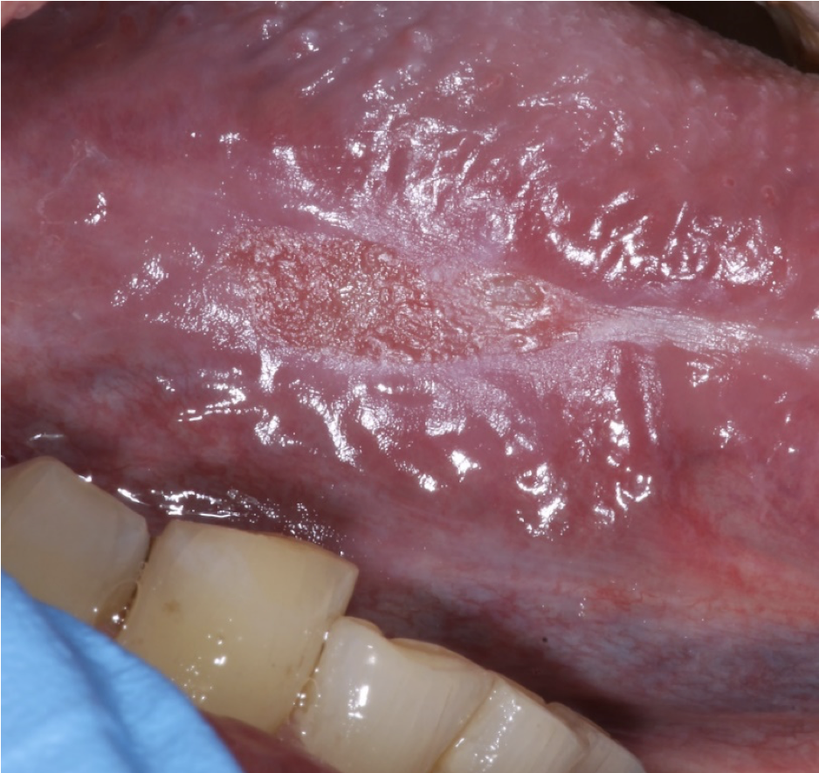 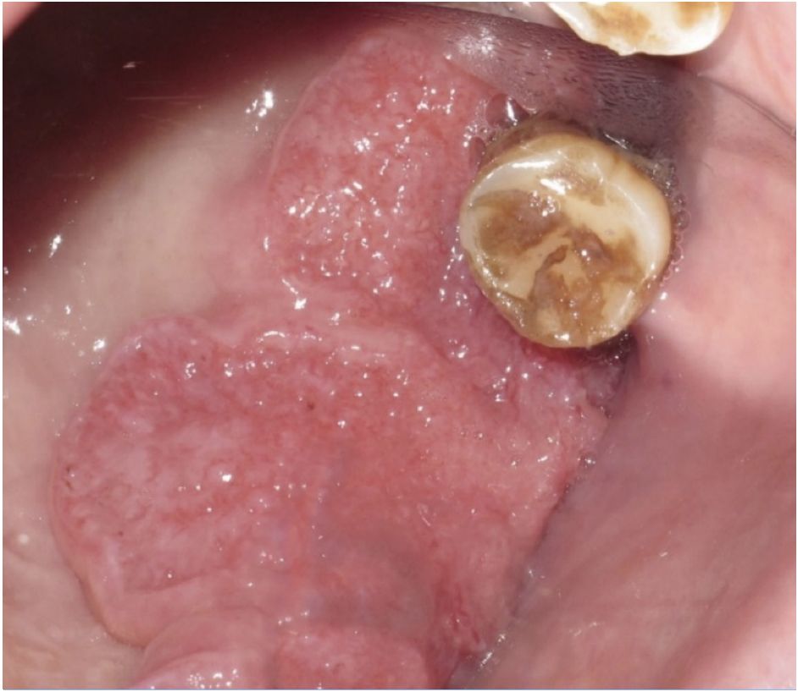

**B**

**Figure 1.** (A) Early-stage squamous cell carcinoma found on the tongue and (B) Late-stage squamous cell carcinoma found on the maxilla.

*Oral cancer signs and symptoms*

Oral cancer refers to cancer that develops anywhere in the mouth. These areas include the lips, gums, tonsils, tongue, salivary glands, back of the throat, roof and floor of the mouth, and cheeks.2,3 Oral cancer will generally be observed by a dental professional during a dental examination, which consists of a visual and tactile examination. Clinically, oral cancer can present as a mouth sore that does not heal, a lesion containing red and white patches with uneven granulation, or other growths and lumps inside the mouth.2,3 Symptoms may include unexplained bleeding, mouth pain, ear pain, sore throat, and difficulty swallowing.2,3 However, the challenge with oral cancer is that cases can be highly variable, and symptoms may not always be present. Sometimes, oral malignancies can go unnoticed and unaddressed until it reaches late-stage squamous cell carcinoma, when mortality risk is greater.

Cancer in the oral cavity most commonly takes the form of oral squamous cell carcinoma, affecting the oral epithelium.4 **Figure 1** shows examples of squamous cell carcinoma (cancer) at different stages. The lesions in this image contain actively growing cancer cells that can proliferate and metastasize to other major organ systems in the body. Upon identification, there is great urgency to diagnose and treat these lesions. Oral cancer can be fatal, and early identification is critical for ensuring the best patient outcome.

*Oral cancer screening timeline*

A typical timeline of the procedure for detecting and treating oral malignancies is outlined in **Figure 2**.5 There are several factors that can delay treatment, extending the time allowed for cancer growth and spread. Because oral cancers are not always symptomatic, they can remain unnoticed by the patient for great lengths of time after emerging.5 In addition, even after a patient discovers an abnormality, they may delay their visit to their dentist for a couple of reasons: Prospective cancer patients might be in denial about the severity of their symptoms, or the cost of treatment might be a dissuading factor, with Ontario Health Insurance Plan (OHIP) not covering dental care.

Once an oral malignancy reaches a dental professional, there is a standard of care that must be followed, requiring additional time.5 Throughout this process, the cancer has time to grow and spread elsewhere in the body, adding complications to surgical removal.

**

**Figure 2**. Timeline of steps between first identification of an oral malignancy and receiving treatment.5

Oral squamous cell carcinoma is often preceded by an OPMD stage (oral potentially malignant disorder).6 Disease prognosis can improve greatly through practicing regular dental screening to identify malignancies at this precursor stage.6 The current standard procedure for oral cancer screening is a clinical oral examination involving a visual and tactile inspection of the mouth.6 The presence of abnormal cell growth may advise the dental clinician to take a biopsy. This biopsy will then be examined by a pathologist for a definitive diagnosis.4,7 Histopathology is the gold standard for diagnosing oral cancers.7–9 A cellular examination of the tissue is currently necessary for accurate identification of oral cancers and determination of the grade and stage of the disease.6 It is unlikely to be replaced for the foreseeable future. If the pathology results return positive for oral squamous cell carcinoma, then treatment is performed, often by surgically removing the tumor.5

Oral cancers can travel and spread to regional lymph nodes and metastasize to other organs in the body, severely worsening prognosis.10 Therefore, screening for oral cancer serves the purpose of regularly evaluating the mouth cavity for abnormalities, catching signs of OPMD before it can become cancerous.6

In contrast to a medical professional diagnosing a symptomatic patient for a disease, screening is the process of evaluating an asymptomatic patient to determine whether there exists the presence of malignant or potentially malignant lesions.6 In dental research, there is some disagreement regarding whether clinical oral examinations are effective at reducing mortality.6 In high-risk patients (defined as users of tobacco and/or alcohol), clinical oral examinations have been shown to reduce overall mortality.6 However, in the general population, there is not enough evidence that clinical oral examinations have resulted in a significant reduction in mortality.6 This sentiment has slowed the consistent practice of clinical oral examinations.

*Past technologies and commercial products to aid with oral screening*

It is difficult to classify the type of lesion based on only the superficial appearance.7 Biopsies and histopathology are necessary for diagnosing oral malignancies. Generally, biopsies are only performed on visually abnormal tissue to avoid unnecessary patient discomfort and to preserve non-cancer tissue. Therefore, biopsies are not always included during a regular screening, contributing to the ineffectiveness of screening in low-risk populations.6

Technologies and products have been invented, intending to aid dental clinician with identifying cancerous lesions.7 VELscope (LED Dental, Burnaby, British Columbia, Canada) is a tool that uses fluorescence to detect abnormal cells.7 However there is insufficient evidence that the VELscope improves on the detection of potentially malignant lesions beyond what can be achieved by a clinical oral examination.7 Tuloidine blue (TBlue, Zila Pharmaceuticals) is a liquid that stains abnormal cells.11 OralCDx BrushTest (OralCDx Laboratories, Suffern, N.Y.) can be used to scrape the top layer of cells, fix them in a glass slide, then send them to the company for evaluation.12 Overall, studies on these tools have revealed problems with sensitivity and specificity for identifying cancer. They have not been reliable enough to recommend their widespread adoption into regular oral cancer screening.7,11

*Optical Coherence Tomography*

Our project was an evaluation of the clinical utility of optical coherence tomography (OCT). OCT is another tool that offers promising benefits for improving oral cancer screening. OCT is an imaging technique that already has a well-established presence in medicine. It plays a key role in in ophthalmology for measuring the thickness of the retina and identifying retinal degenerative diseases.13 It presents exciting applications for enhancing our capacity to identify oral cancer early in its development.

OCT is a light-analogue of ultrasound, using lasers instead of pressure waves.14 Ultrasound can reach greater depths of penetration, but is limited by its lower spatial resolution when compared to OCT.15 The reason OCT is likely to be more successful than previous technologies and products developed for oral screening is that OCT is a high resolution structural imaging technique and has the potential to reveal much more detailed information about microscopic structures in oral tissue.15 Histology is effective for providing a good visualization of cellular appearance and composition, making it very effective for diagnosing cancer. In contrast, OCT images contain quantitative information that can undergo computational data analysis.15

**B**

**A**

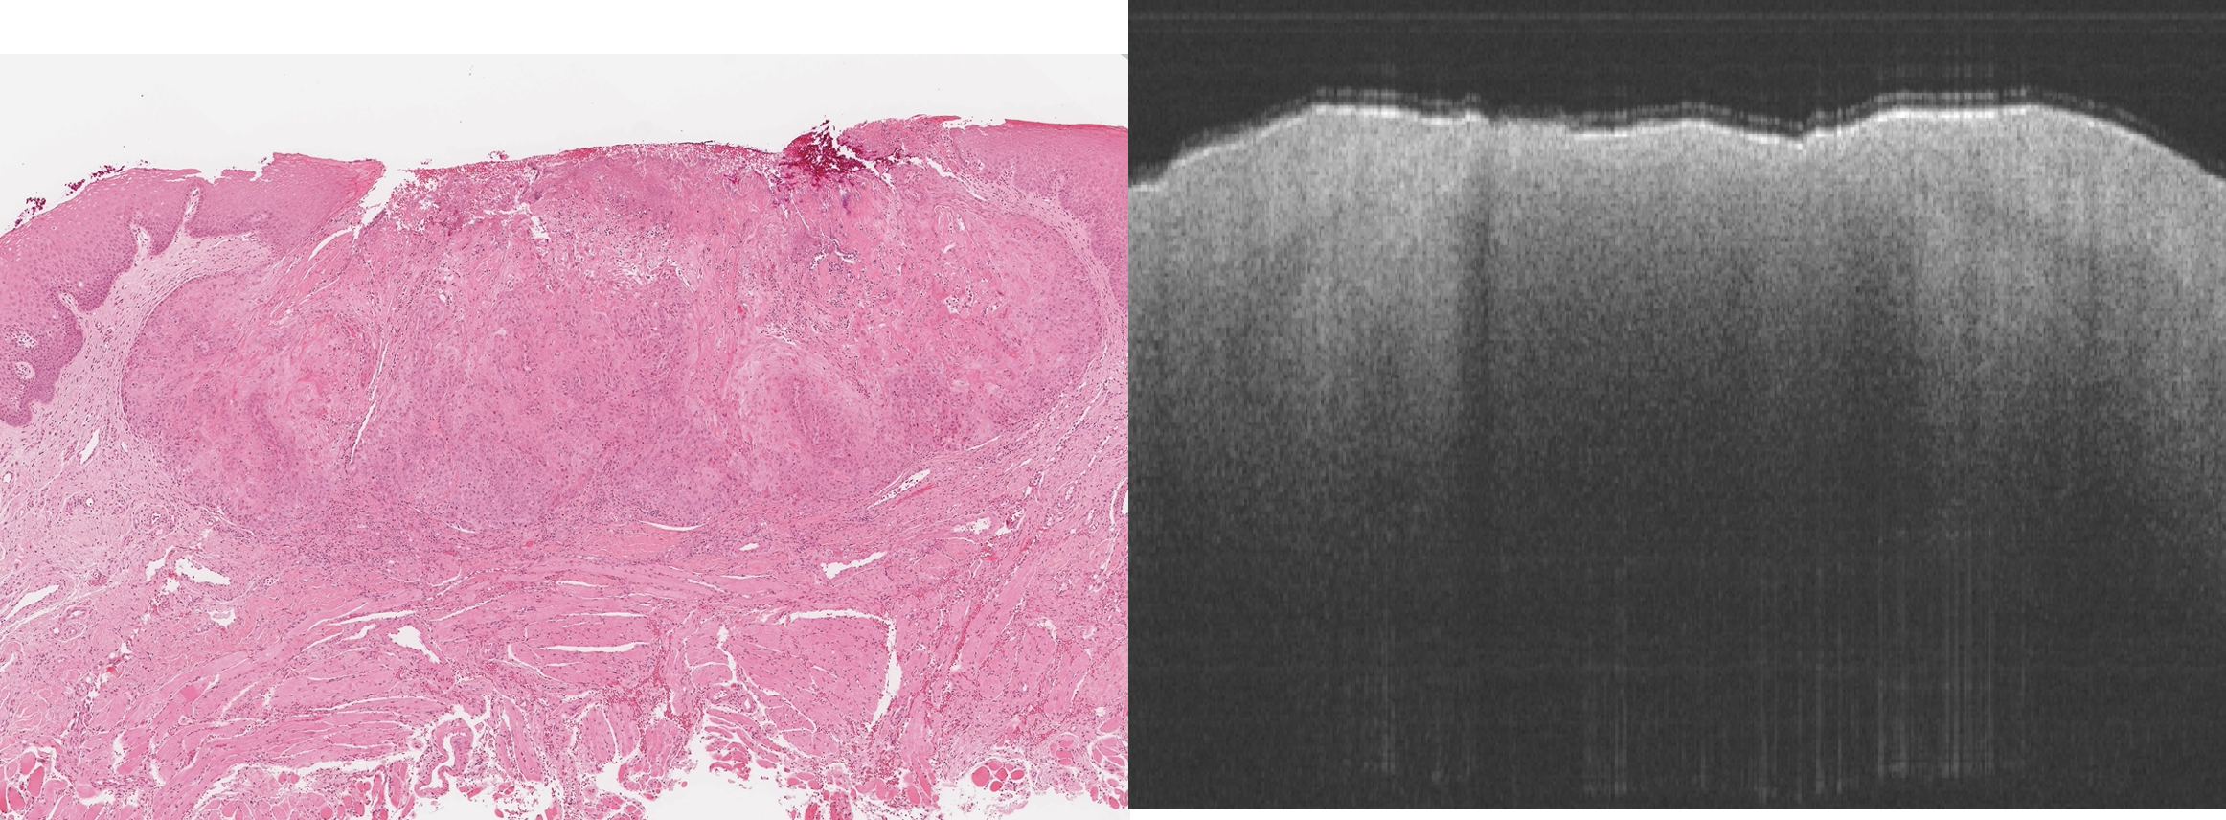

**Figure 3.** (A) Histology slide of oral tissue and (B) the image created by OCT of the same tissue.

The depth of penetration of OCT is dependent on the type of tissue. It can reach around 1-3mm in oral epithelium, making oral tissue an appropriate candidate for this technique. The OCT system makes an incident beam and returns an interference pattern representing light-matter interactions within a tissue sample. Using this data, we can apply computational methods and data analysis algorithms to learn more about what OCT can reveal about tissue structure. We are making quantitative measurements using the tissue’s optical properties and investigating its utility in oral cancer screening. Previously, only qualitative observations have been possible.

**

**Figure 4**. Schematic illustration of the Santec SS-OCT system.15

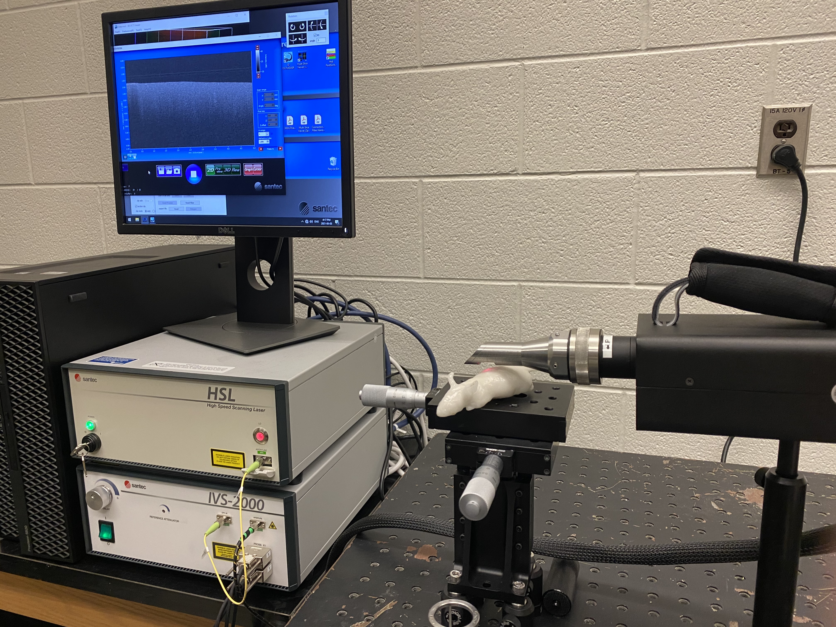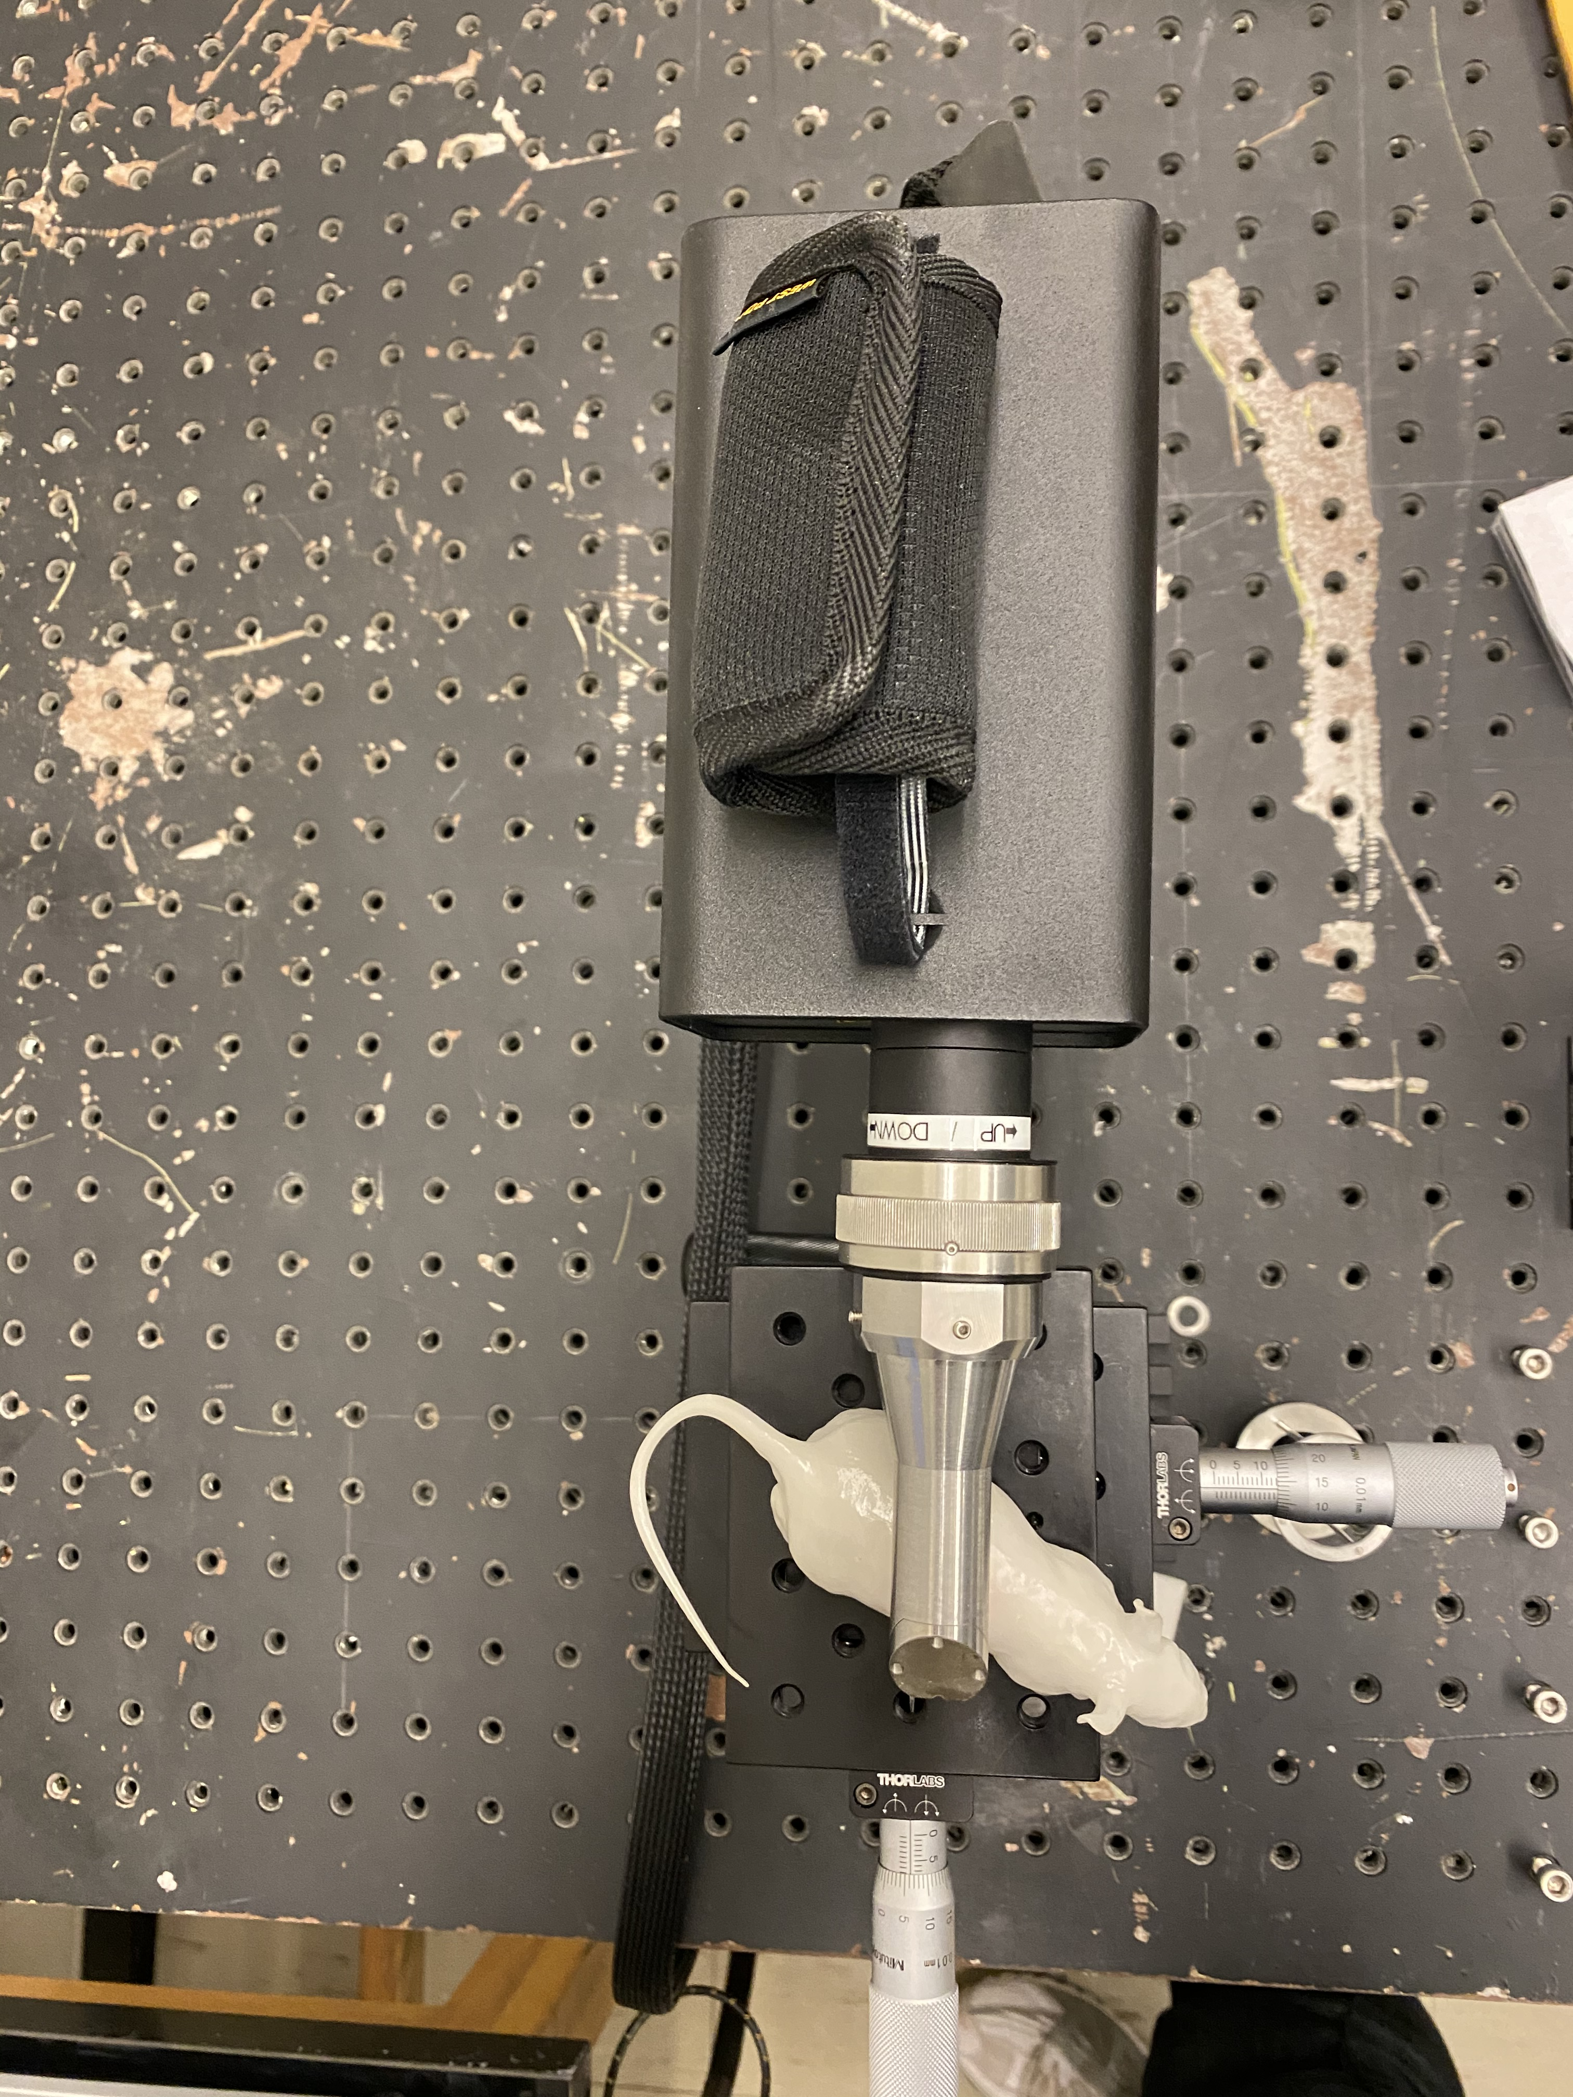

**Figure 5**. Lab photo of the swept-source OCT system (developed by Santec).

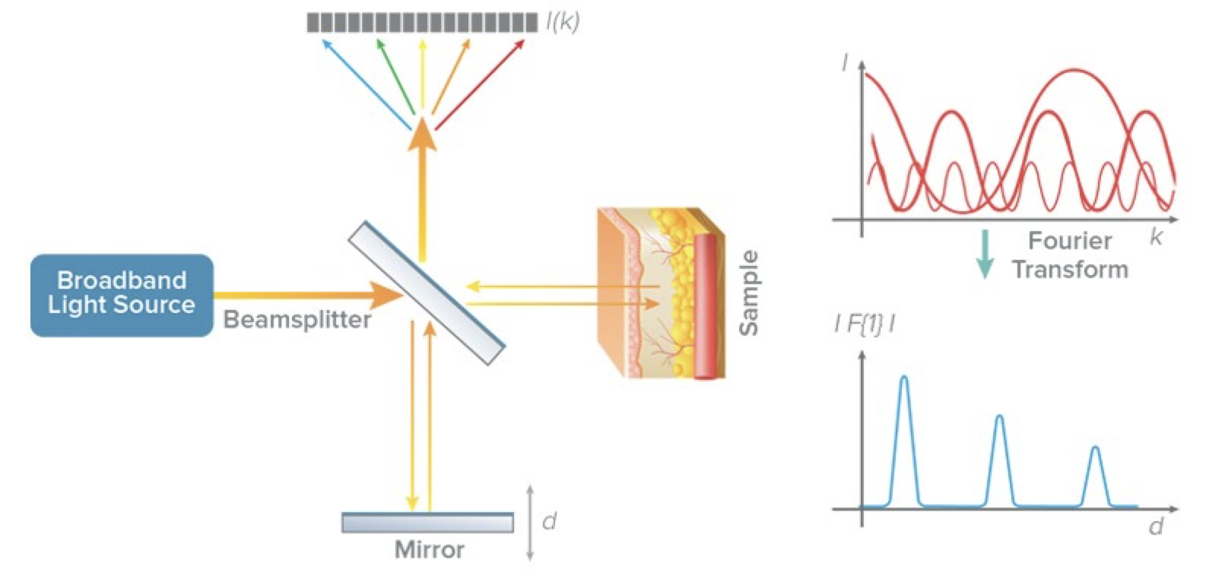

**Figure 6.** Schematic of the creation of OCT images.16 The incident beam is split into a reference arm and a sample arm. The reference arm reflects off of the mirror, and remains identical to the original signal. The sample arm reflects off of the sample with an altered signal. The sample and reference arm are compared to generate an interference pattern that undergoes a Fourier transformation.

*OCT in past cancer research*

Interest in OCT is growing to determine its utility as a tool for multiple different types of cancer. In addition to being used in ophthalmology, OCT has been used in cardiology17, gastroenterology18, and dermatology19.

A lot of research is being done to explore methods of quantitatively analyzing OCT data. Research in using OCT on oral tissue has investigated the potential of computing an attenuation coefficient as a quantitative measure for identifying oral cancer. Yang et al. used an attenuation model adapted from the Beer-Lambert law, that includes a confocal point spread function (PCF) for calculating attenuation coefficients.8 They found that their attenuation model could identify oral squamous cell carcinoma at 91.15% accuracy.8 A study investigating the delineation of surgical boundaries around an oral tumor also reported that OCT can identify malignant oral cancers with strong concordance when compared with histological diagnosis (kappa, ĸ= 0.922).9 Both studies emphasized that implementing the power of OCT intra-operatively in the clinical setting can solve challenges associated with current clinical-based tumor assessment and screening.8,9

OCT is gathering a lot of interest and discoveries are being made of its many promising benefits on different types of biological tissues. However, OCT research is still a growing field, and we are pursuing different methods of analysis for better interpretation of OCT data.

*Attenuation of light*

Light attenuation is an optical property of tissue that has been the focus of past OCT research.4,20–22 The OCT system measures the light intensity of the reflected beam detected by the photodetector.23 The intensity of the reflected beam will be reduced compared to the incident beam due to two structural properties of the tissue: the scattering of light and the absorption of light.23 Combined, they contribute to the attenuation of light, defined as the gradual decay of light intensity as it travels through a medium.24 In other words, the maximum amount of reflected light intensity is recorded at the surface of a sample, then, as the laser descends deeper into the sample, it interacts with the tissue cells and decays in strength. Depending on the tissue, the amount of attenuation will vary. Our hope in this study is that we can use the difference in optical properties of tissues, and therefore, a difference in attenuation, to discriminate between cancerous and non-cancerous oral tissue.

To illustrate differences in light attenuation, **Figure 7** shows two solutions of different concentrations (Solution A = 1%, Solution B = 13%). These images are generated by an OCT system, where the incident beam is coming from above the sample. For solution B, which has a greater concentration, the light signal decays to 0 much quicker with respect to depth when compared to solution A. In the intensity-decay curve, it is evident again, that the slope of the intensity decay for solution B is steeper (ie. intensity is decreasing faster with respect to depth in solution B). And thus, solution B has greater light attenuation. Using the principles of light attenuation, we can calculate an *attenuation coefficient* from the OCT images.

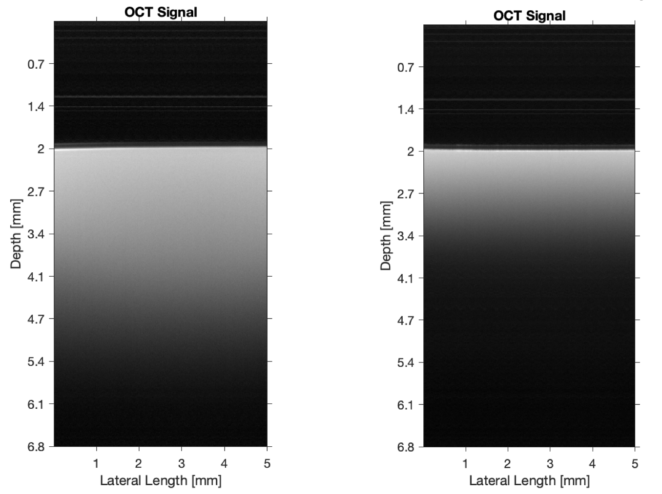

**A**

**B**

**A**

**B**

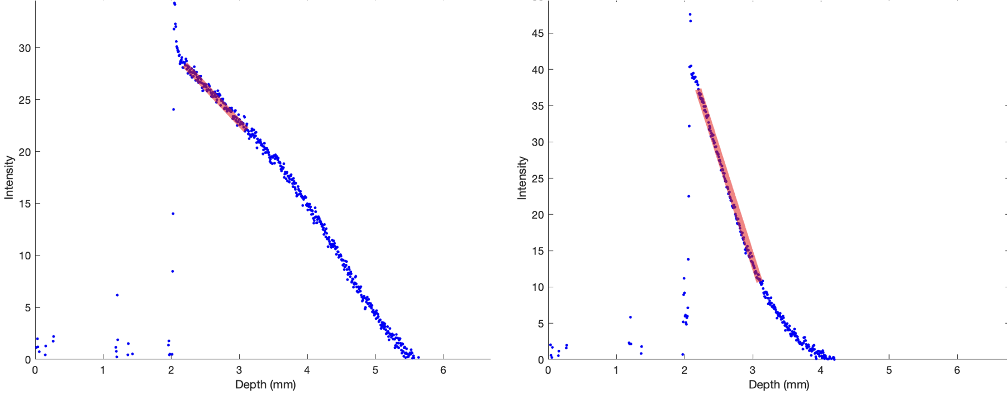

**Figure 7.** The OCT signals (Top) for solutions of different concentrations (A = 1% w/v, B = 13% w/v). And the intensity-decay curves (Bottom) for these two solutions.

Observing OCT images alone is not sufficient for distinguishing cancerous tissue from normal tissue. Computation is involved to measure the decay of light and produce an attenuation coefficient.8,23,24

In clinical cases where a biopsy is taken from a patient presenting with OPMD, the diagnosis may return negative. However, there may still be concern that the abnormal area will eventually develop into malignant tissue. In such cases, the dental clinician may want to re-evaluate the area during subsequent patient visits, taking additional biopsies. However, this process can be painful and time-consuming.8 In contrast, OCT is non-invasive, causing less discomfort to the patient. Scans can be done quickly and easily, without needing to send specimens to the lab. OCT can potentially be used for long-term surveillance of potentially malignant tissue. Only if a significant change in attenuation coefficient between visits is observed, might there be a reason to take a biopsy for further histopathological diagnosis.

*Objectives*

1. Develop a MATLAB program and implement data modelling algorithms for OCT data analysis

2. Determine whether attenuation coefficients can be used to differentiate between cancer and non-cancer oral lesions.

**Methods**

*Sampling design*

We used the OCT system to scan images of oral patient biopsies at Western University Hospital, London, Ontario. Biopsies were fixed in formalin before scanning OCT images. Afterwards, the biopsies were embedded, sliced, and stained. Then, they were examined histologically by a Western University pathologist to make a diagnosis for the patient.

These biopsies were collected from prospective oral patients, meaning that these are patients who had a biopsy taken from a lesion in their mouth to make a medical diagnosis. As a result, we could not know beforehand how many cancerous samples and how many benign samples would be included in our dataset.

We collected OCT scans from 248 patient biopsies. Of these, 6 patients were diagnosed with squamous cell carcinoma (SCC, cancer), and 18 were diagnosed with hyperkeratosis. Hyperkeratosis is a type of benign lesion that is used as an approximation for normal tissue. Completely healthy, normal tissue was not included in our dataset because it is not common clinical practice to collect biopsies of normal tissues. Among the remaining patients, there are a variety of other diagnoses including varying degrees of dysplasia (low dysplasia, moderated dysplasia, high dysplasia), types of cysts, ulcers, bony lesions, and more.

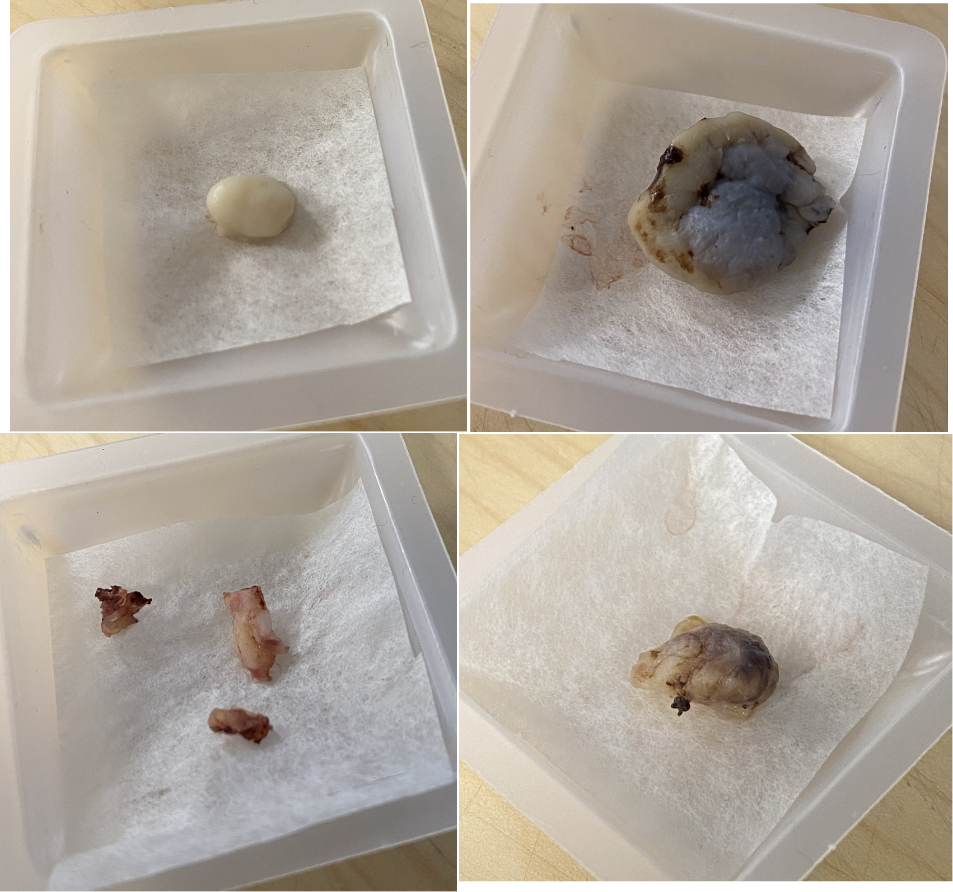

**Figure 8**. Photographs of oral tissue biopsies.

Our analysis focuses on the extreme ends of the spectrum for cancer diagnoses, namely, squamous cell carcinoma and hyperkeratosis. For some patients, more than one biopsy, from different areas of the lesion, may have been taken. For all biopsies, we used OCT to scan three images from different cross-sectional areas of the sample. Therefore, there can be unequal numbers of images per patient, depending on how many biopsies were collected from them.

*Modelling attenuation coefficients*

To measure attenuation coefficients, we used the principles of the Beer-Lambert Law. The Beer-Lambert Law describes light intensity decay as it travels through a medium. We implemented two different models of the Beer-Lambert Law using MATLAB,25 and they differ in small ways.

*Simple Beer-Lambert Model*

The simple Beer-Lambert equation (**equation 1**) calculates the attenuation coefficient as the change in light intensity (I) with respect to depth (z). The equation describes an exponential decay of light, and can be log-transformed to visualize a linear decay instead. Our data has been log-20 transformed. Going forward, our calculations were done using the log form of the equation, and thus, our results show linear decays.

**(1)** 21

*Modified Beer-Lambert Model*

The modified Beer-Lambert equation (**equation 3**)4,21 builds on the simple Beer-Lambert model by introducing a confocal point spread function (CPSF, **equation 2**), h(z), to account for confocal properties of the OCT system that we are using. These factors include the focus position (zcf), and the Rayleigh length (zR). Depending on the distance of the tissue sample from the OCT system, the difference in focus position from sample-to-sample might alter the image. The Rayleigh length refers to half the depth of the focus. For our OCT system, the zcf and zR values used in our calculations were 3.4 mm and 0.239 mm, respectively.

**(2)** 4,21

**(3)** 21



**Figure 9.** Schematic of the focus position of a lens in different areas of a sample.21

*Implementation of the models using MATLAB*

We created a program in MATLAB (R2021a)25 for analyzing OCT data. This program takes raw OCT data as input and applies either the Simple Beer-Lambert model or Modified Beer-Lambert model for generating results. Recall that the Modified Beer-Lambert model is similar to the Simple model, but also includes a CPSF. The program offers customizability through a variety of different floating parameters.

We decided not to calculate attenuation coefficients using just the change in intensity pixel-by-pixel (traversing the tissue one pixel at a time). Instead, we divided the image into 5-pixel-by-5-pixel blocks. The problem that we anticipated we might find when using 1-pixel increments is that OCT data can be noisy, and we might see very erratic changes on a pixel-by-pixel basis. By averaging over 5-pixel blocks, we are achieving two things. First, we are reducing noise in the image. Second, we are obtaining local spatial information in the tissue, assuming that certain interesting landmarks can be contained within our 5-pixel blocks. The size of these blocks does not necessarily need to be set at 5 pixels. However, it is important to avoid using blocks that are too large, such as 100-pixel-by-100-pixel. Large blocks would potentially result in too much smoothing of the image, losing detail and critical information.

We proceeded with our analysis using 5-pixel-by-5-pixel blocks because it appeared to have a good balance of noise reduction and capturing local landmarks, while also retaining good detail in the image. There might be a wider spectrum of pixel sizes that could work just as well or possibly better. So, although we decided to use 5-pixel blocks, additional analyses should be done using a variety of different pixel sizes and observing the effect on the results.

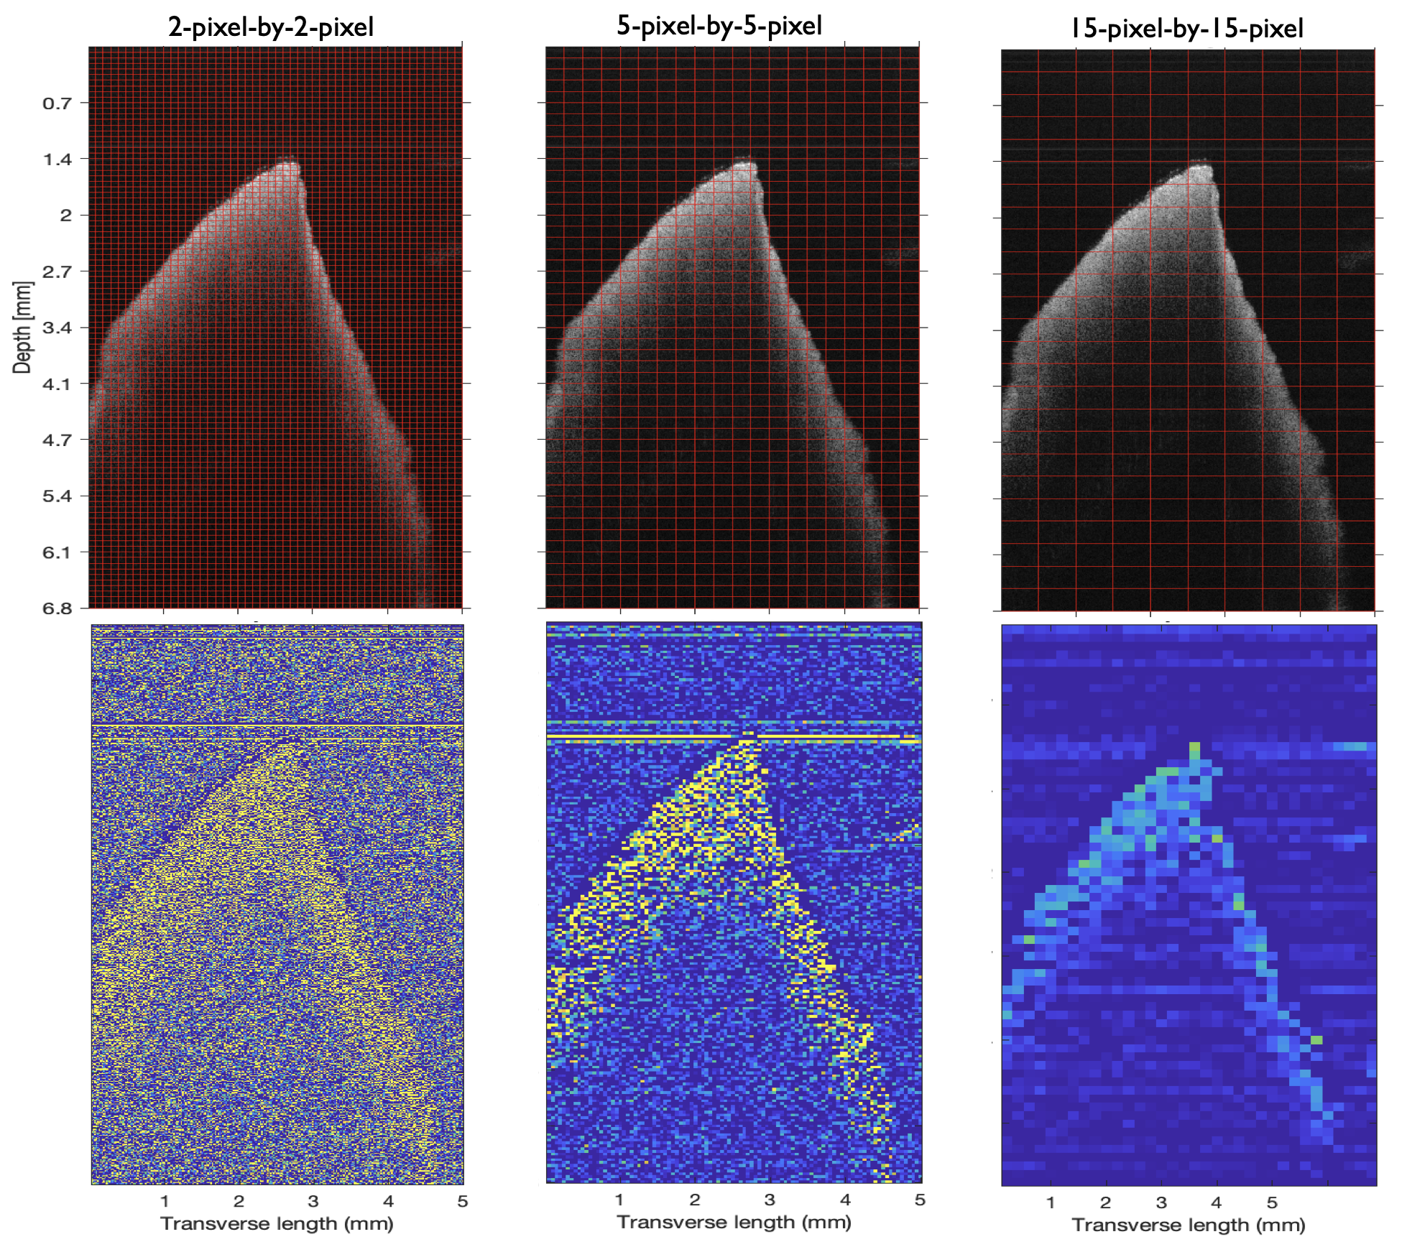

**Figure 10.** Demonstration of the smoothing effect of different block-sizes (top) on the output (bottom). Blocks not to scale (enlarged for visibility).

Our raw OCT data is in the form of a 500 x 1000 matrix containing intensity values. The visualizations in **Figure 10** are essentially heatmaps representing the values in the matrices.

The size of these images in terms of real measurements is 5.00 x 6.78 millimeters in the lateral and axial directions, respectively. This means that a single pixel has a width of 10.00 microns and a height of 6.78 microns. And the real size of a 5-pixel-by-5-pixel block is 50.00 x 33.90 microns.

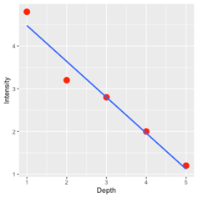 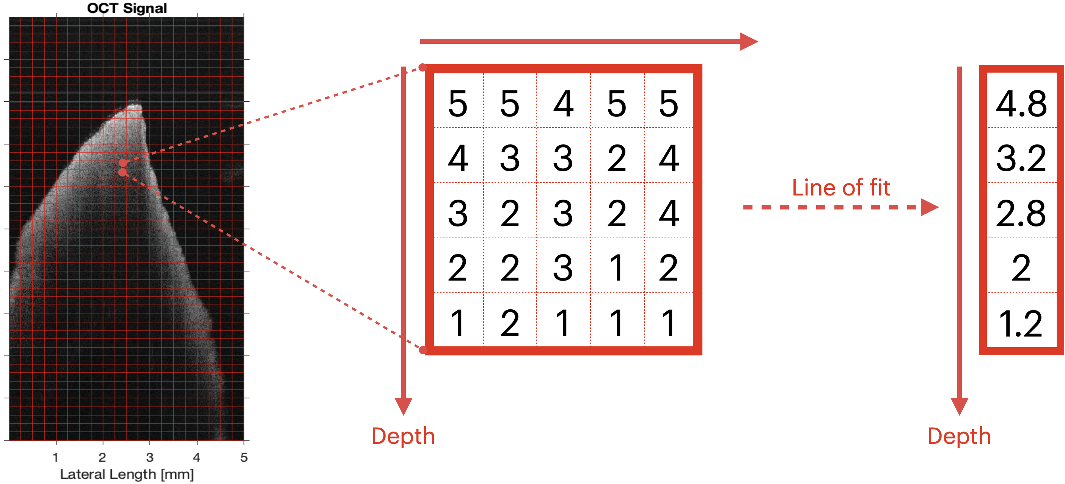

Column-vector average

**Figure 11**. Example demonstration of the sequence of steps performed within every 5-pixel-by-5-pixel block.

Within every 5-pixel-by-5-pixel block, the model is calculating a line of best fit of intensity vs depth. The slope of this line, $\frac{ΔI}{Δz}$ is proportional to the attenuation coefficient, $μ$, because attenuation describes the decay in light intensity with respect to depth.

This calculation produces slopes in units of pixels-1. To convert it to a real measurement, such as millimeters, we need to first recall that the height of a pixel is 6.78 microns. To calculate attenuation coefficients in units of mm-1, we need to divide the slope by the height of a pixel (equation 4).

$\frac{\frac{ΔI}{Δz}}{0.00678}$ (units: mm-1) (4)

*Attenuation Map*

The Simple Beer and Modified Beer algorithms consist of several data analysis steps for computing attenuation coefficient values from OCT images.

The result of these various analysis steps is that we obtain an *attenuation map*, which represents the data from the original OCT image as attenuation coefficients, rather than light intensity values. Recall that the raw OCT data comes in the form of a 500 x 1000 matrix of intensity values. Then, we algorithmically computed lines of best fit through every 5-pixel-by-5-pixel bock to determine an *attenuation map*. Rather than intensity values, the pixels in the attenuation map represent attenuation coefficients. In other words, an attenuation map is an aggregation of slopes of intensity vs depth fitted within every 5-pixel-by-5-pixel block. Additionally, due to the fitting and averaging within 5-pixel blocks, both dimensions of the attenuation map are reduced by 5, and thus, the output is a 100 x 200 pixel matrix. The dimensions of the attenuation map will differ depending on the block-size used for averaging in the analysis.

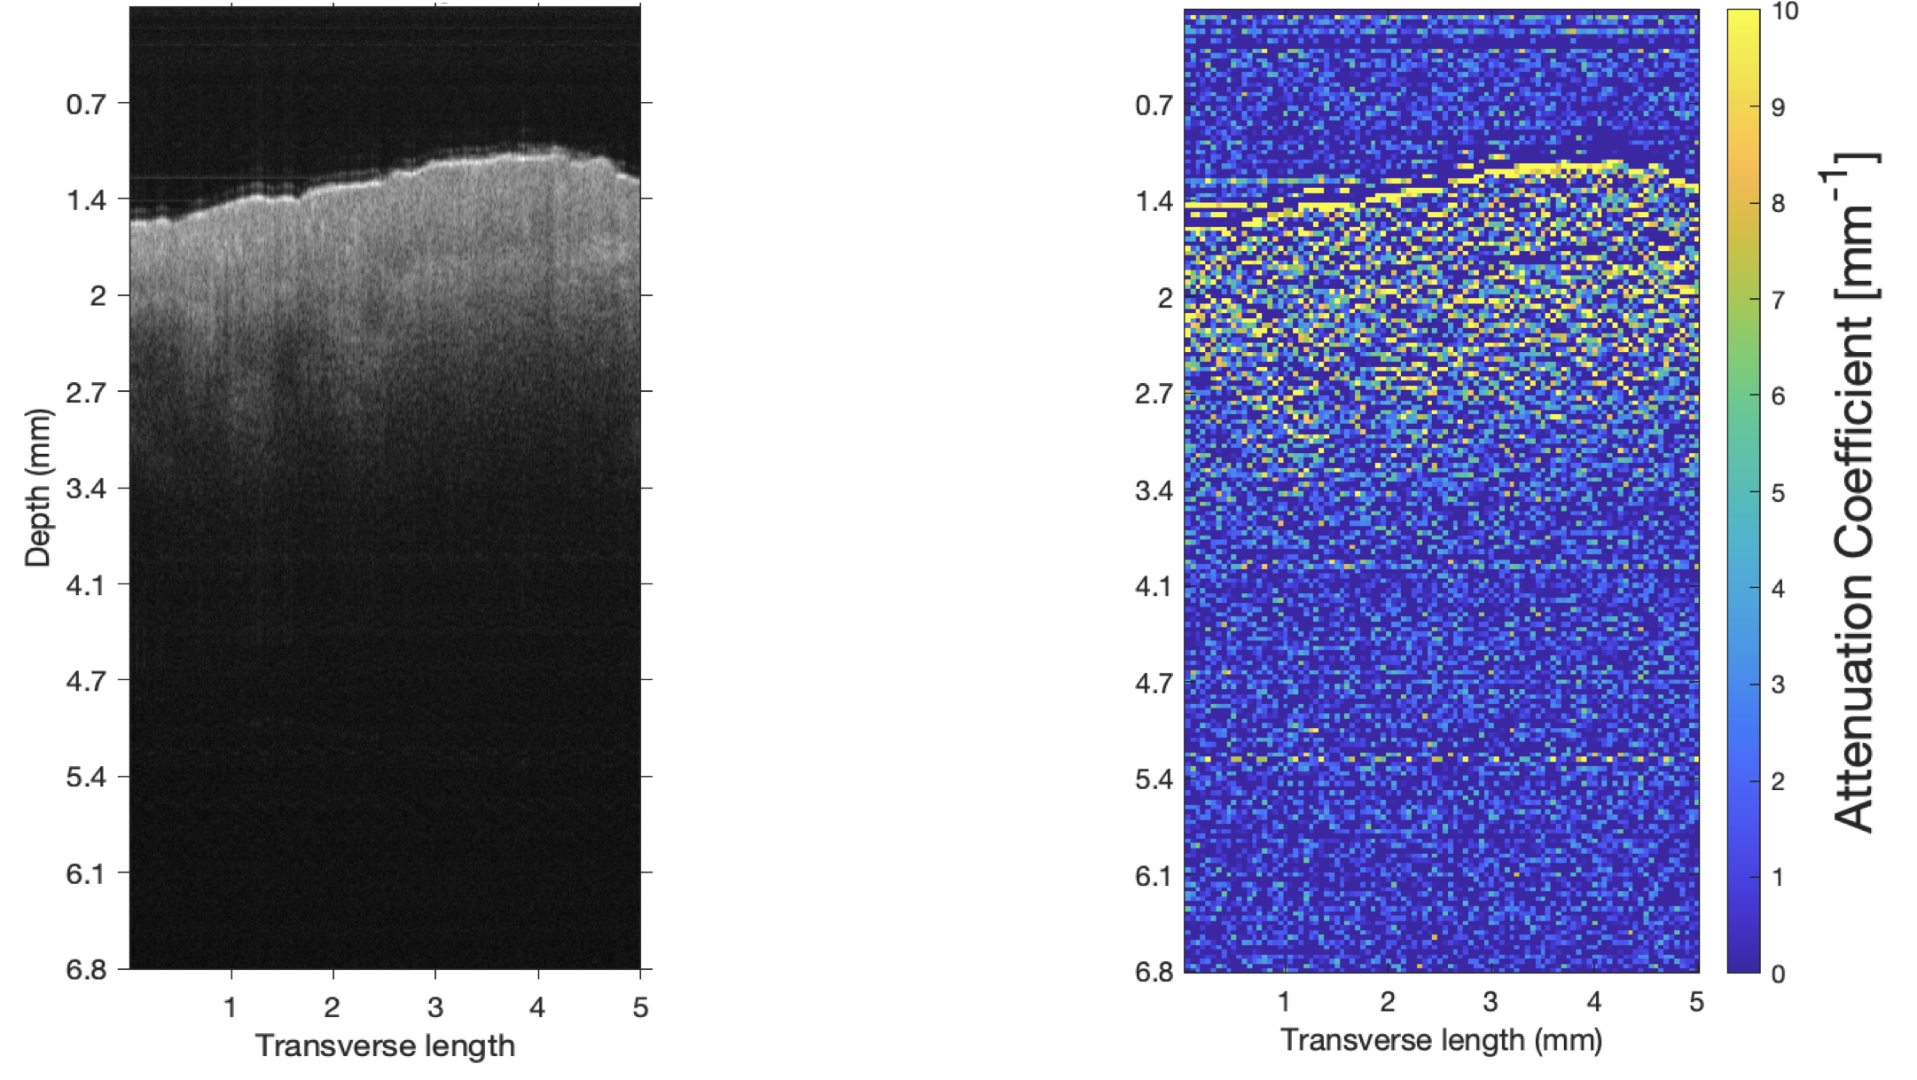

**B**

**A**

**Figure 12**. Input OCT data (A) and the output attenuation map (B) after using the Simple Beer-Lambert Model to compute attenuation coefficients.

*Implementation validation using intralipid liquid phantoms*

OCT research is still new, and our project is exploring new methods for analyzing OCT data. It is important to validate that our methods are producing accurate results that can be interpreted in the context of past studies. To validate that our implementations of the Simple Beer-Lambert and Modified Beer-Lambert models are producing accurate results, we calibrated them using intralipid liquid phantoms (phantoms are imitations of tissue). Intralipid phantoms are commonly used as a calibration tool in OCT research, so we can easily obtain reference values for comparing attenuation coefficients.20,21

We validated our code using 4 different concentrations of intralipid: 1%, 4%, 13%, and 20% (w/v). These concentrations were chosen because they give us a wide range of attenuation coefficients to compare against other literature.

Figure 11 shows the trend of our calculated attenuation coefficients against intralipid concentration. Our OCT system used a wavelength of light of 1300 nm, and can be compared to the attenuation coefficient curve in **Figure 14** (black), which used a wavelength of 1300 nm. There is a non-linear rise in attenuation coefficient with increasing concentration, reaching a plateau near 5 mm-1. This trend matches what is found in literature, and the exact values are comparable as well.

Both models computed nearly identical attenuation coefficients, and both were consistent with previous results found in literature. We concluded that the Simple Beer model is computing sufficiently accurate attenuation coefficients, so we were confident enough to move forward with our analysis of patient tissues.

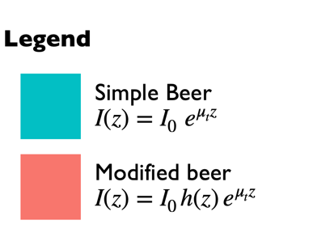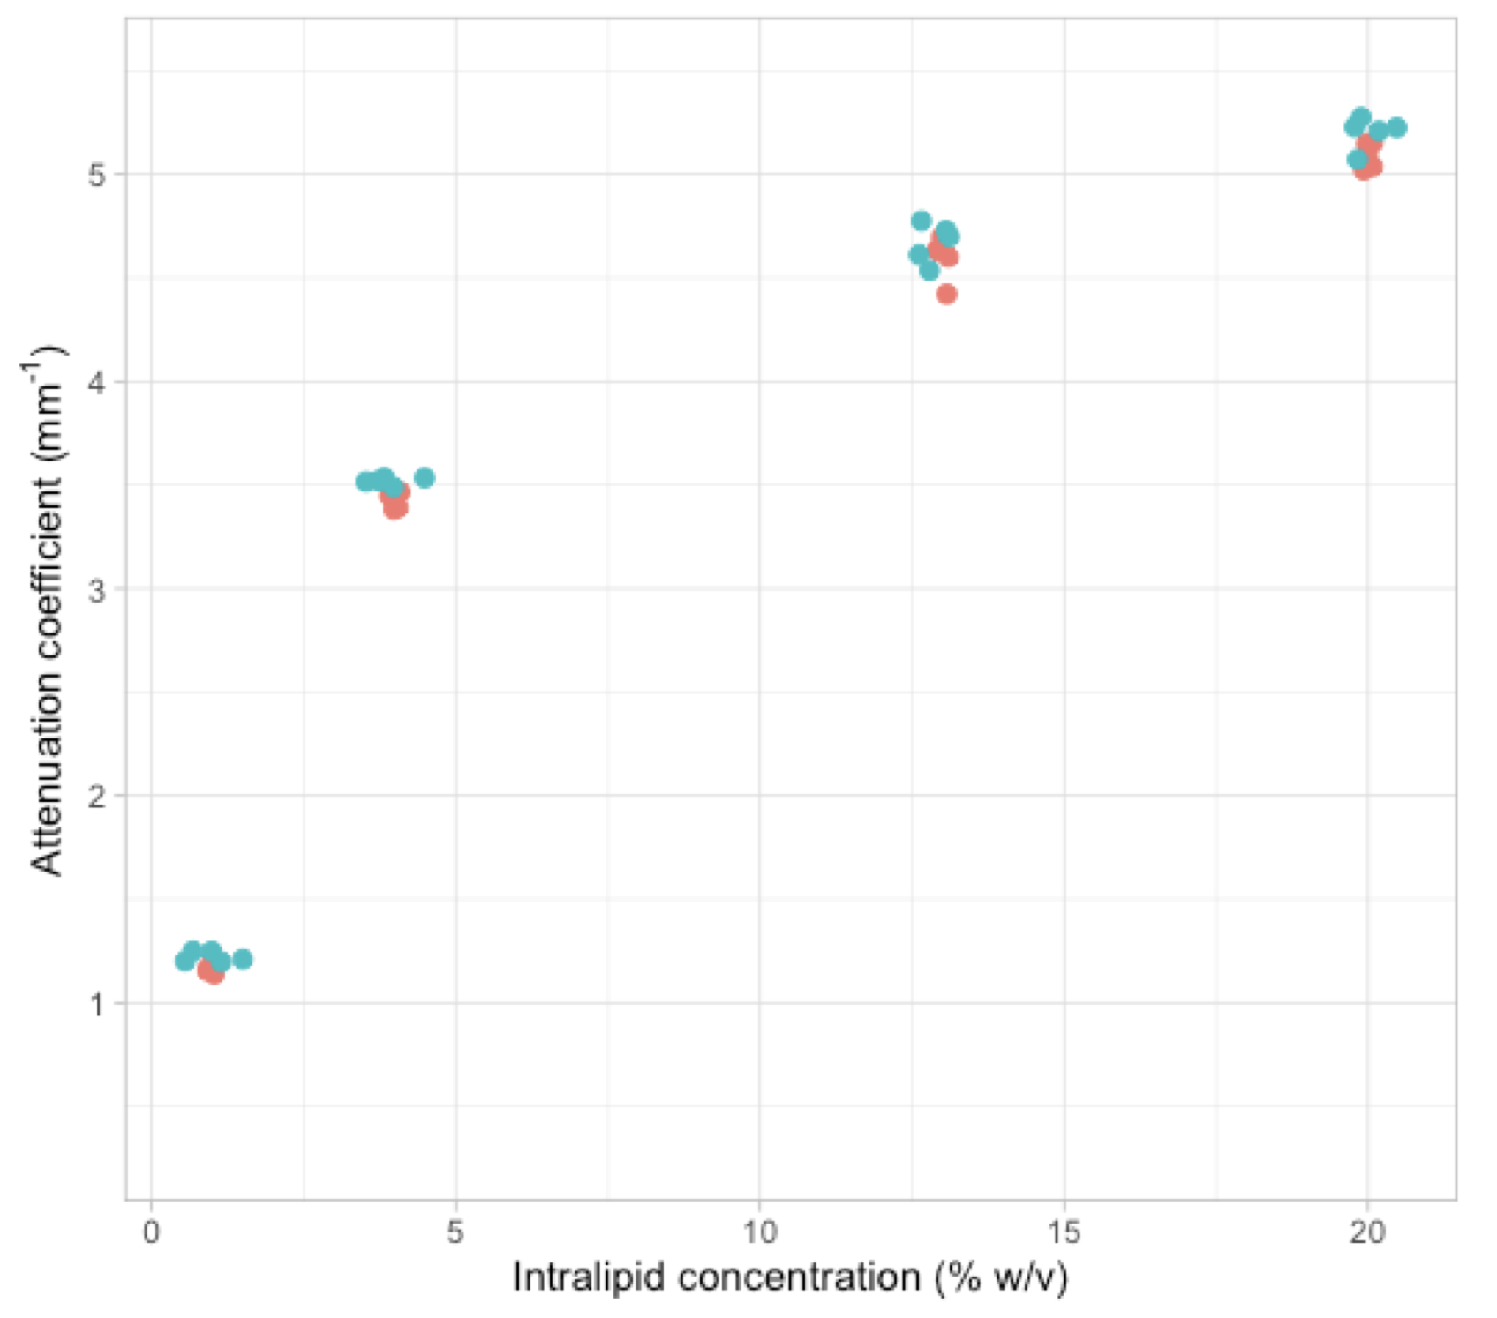

**Figure 13**. **Our intralipid results:** Attenuation coefficient, $μ_{t} (mm^{-1}),$ vs intralipid concentration (% w/v) for our implementations of the Simple Beer (blue) and Modified Beer (red) models. Wavelength of light = 1300 nm.



**Figure 14**. **Intralipid results from Faber et al.:** Attenuation coefficient, $μ_{t} (mm^{-1}),$ vs intralipid concentration (% v/v) for wavelengths of light of 1300 nm and 1600 nm.

*Collecting attenuation coefficients from patient tissues*

The goal is to obtain an attenuation coefficient value from OCT images for all our squamous cell carcinoma and hyperkeratosis data. As a reminder, OCT images were created from oral cancer patient biopsies. We selected regions of interest within images to obtain average attenuation coefficients that are representative of individual samples. Region selection was informed by histological landmarks. As well, we tried to retain as many data points as possible while avoiding uninteresting regions, such as the air, or deep in the tissue where OCT signal is lost (when the signal decays to 0).

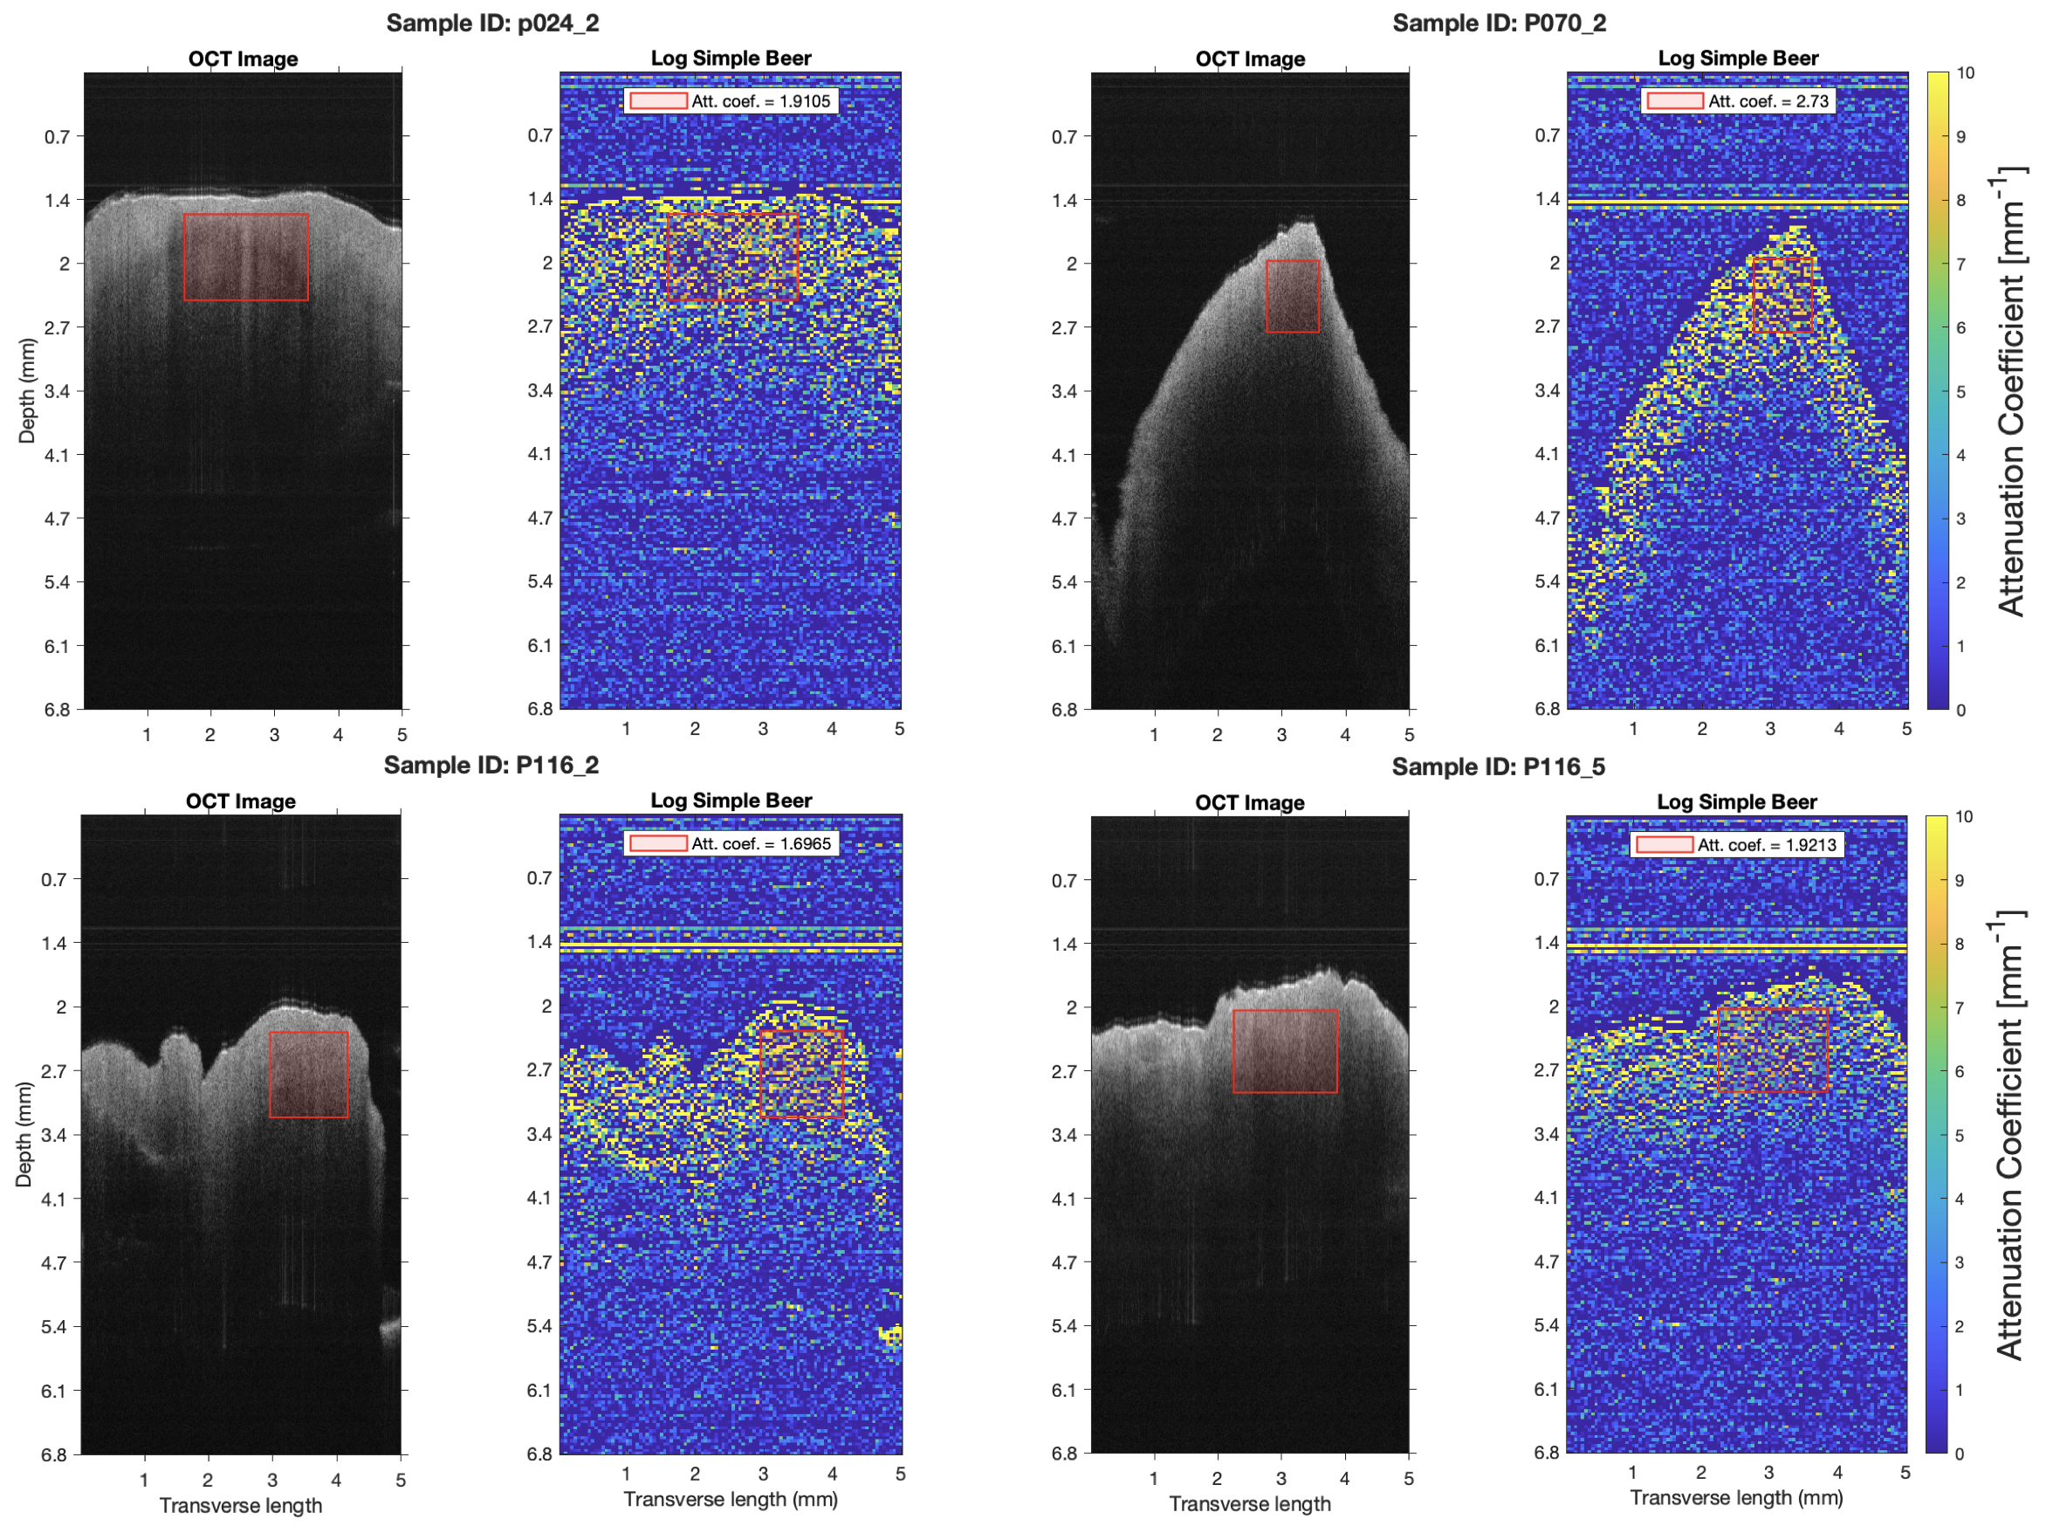

**Figure 15.** Examples of region selection in patient tissues (red boxes).

*Statistical Analysis*

Our research objective was to determine whether computing an attenuation coefficient from OCT data can discriminate between cancer and non-cancer. To answer this question, we performed a Welch’s t-test26 using R programming language.27 The Welch’s t-test is a 2-sample unequal variances t-test that can be used when the two groups being compared are normally distributed.26,28 We tested for significant differences between attenuation coefficients from squamous cell carcinoma and hyperkeratosis biopsies. A p-value ≤ 0.05 was considered statistically significant.

**Results**

*Sampling design and data collection*

Our OCT system was used to scan images of oral tissue biopsies. Biopsies were taken from the lesions of 6 patients who were diagnosed with squamous cell carcinoma (cancer), and 18 patients who were diagnosed with hyperkeratosis (benign). Between patients, lesions were found in different anatomical locations of the mouth. Anatomical site of biopsy may potentially affect our results, but were not accounted for in this analysis.

For most patients, only a single biopsy was taken per patient. However, there are some cases where multiple biopsies were taken from a lesion. OCT was used to scan three different cross-sectional scans from each biopsy sample. Therefore, for most patients, there are 3 OCT images (matrices) included in our dataset. For a small number of patients, where multiple biopsies were taken, there may be 6 or 9 OCT images included in our dataset for these patients. In total, we have 24 images for squamous cell carcinoma, and 57 images for hyperkeratosis.

However, an important note is that although we have categorized our samples as either “SSC” or “hyperkeratosis”, we cannot expect samples within the same group to be truly identical in their tissue composition. Cancer growth is random, it can be more heterogeneous in some patients compared to others.

After the analysis steps outlined in the methods section, we have obtained one average attenuation coefficient value for every OCT image (24 attenuation coefficients for SCC and 57 attenuation coefficients for hyperkeratosis).

*Statistical analysis: prior to quality control*

The Shapiro-Wilk normality test in R is used to confirm that our data is normally distributed. A p-value from this test ≥ 0.5 means that there is no evidence to suggest that the data is not normally distributed. Using the Shapiro-Wilk normality test on the cancer and hyperkeratosis data prior to performing quality control steps yielded p-values of 0.0347 and 0.435, respectively. The value of 0.035 for cancer attenuation coefficients is too low and indicates to us that the data is not normally distributed and that a t-test would not be appropriate.

**Figure 16** shows the distributions of attenuation coefficients for cancer samples and hyperkeratosis samples. It is clear in the figure that the distribution for cancer samples is nearly bi-modal, which explains why it failed the Shapiro-Wilk normality test.

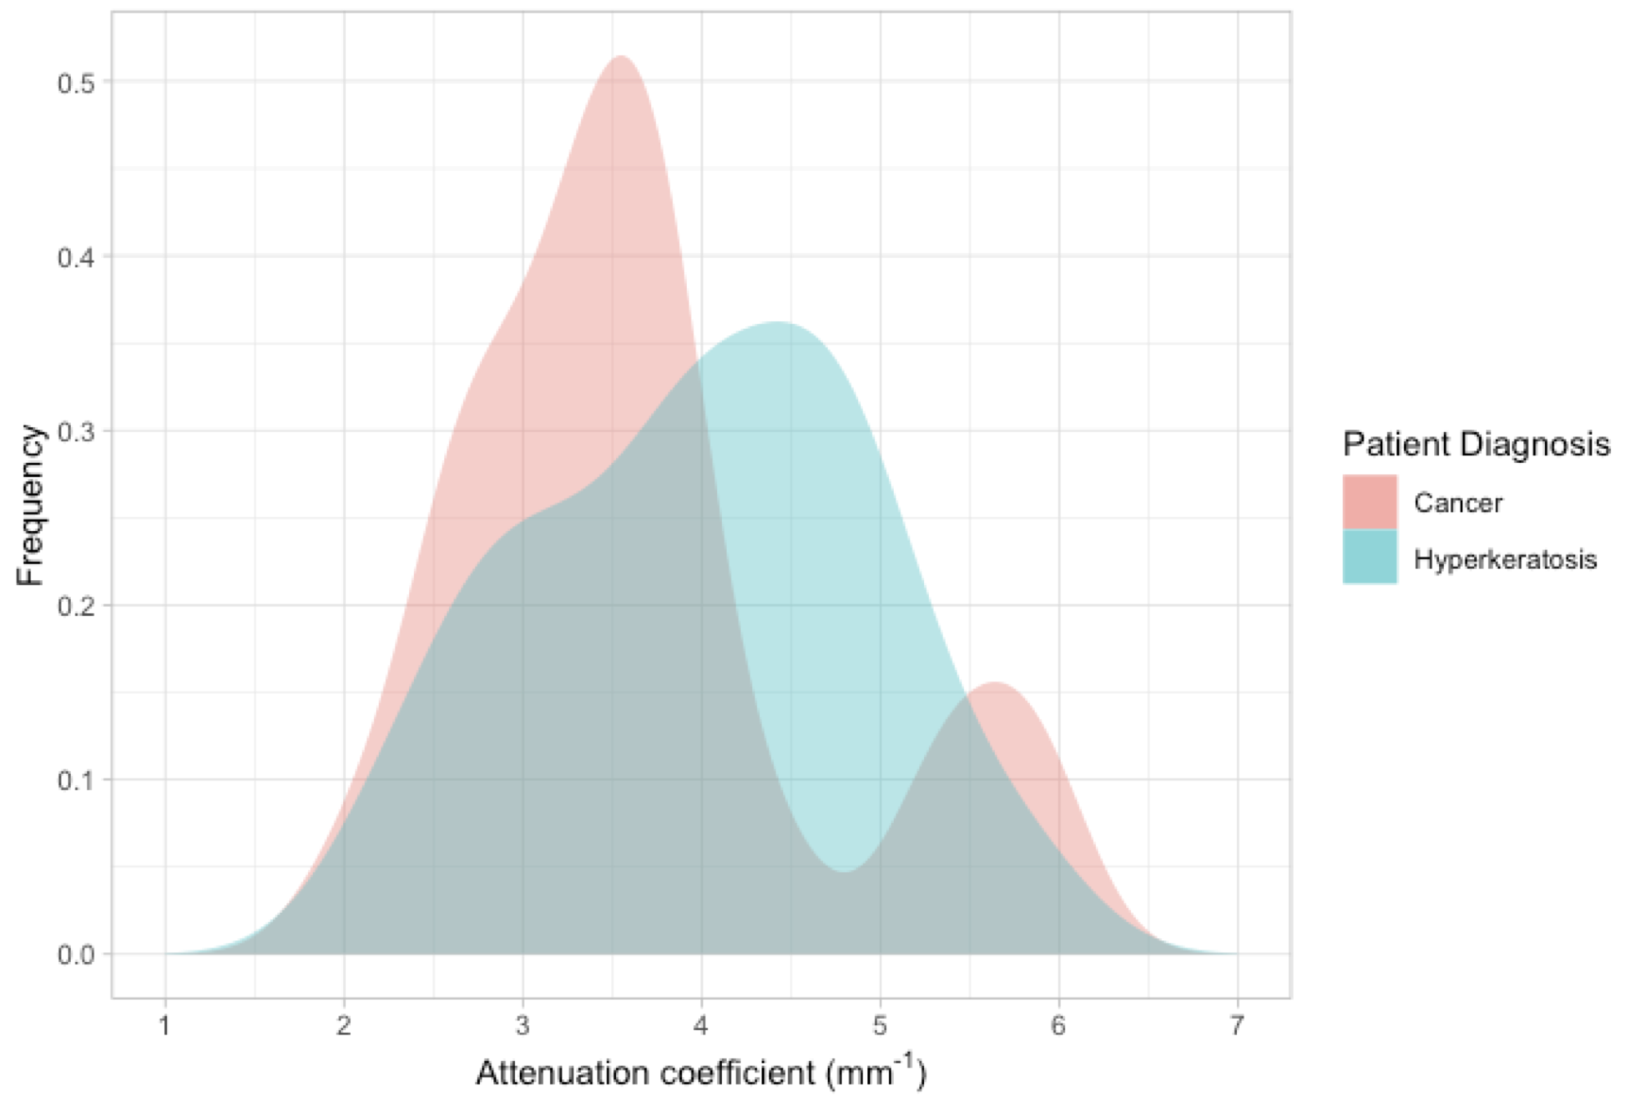

**Figure 16. Prior to quality control of data.** Density plots of attenuation coefficients calculated using the Simple Beer-Lambert Model. Distributions for cancer samples (red) and hyperkeratosis samples (blue). Density plots created using the R package ggplot2.

*Statistical analysis: after quality control*

It was previously observed that the number of images per patient was not equal across all patients. Both the cancer and hyperkeratosis groups contained 1 patient each who had more than one biopsy taken, and thus, had more OCT images included in the dataset. Investigating the images from these patients more closely, it became clear that some of the additional images for these patients might have been inappropriate for our analysis. Some images contained image artifacts (that is, there are structures in the image that are artificially created during the OCT scanning process, rather than representing real data). It is very difficult to select appropriate regions of interest when artifacts are present in the image. We cannot be confident that the data included in our selected regions contain real information. Other images did not have artifacts, but nonetheless, their shapes made it difficult to select large areas for obtaining a representative attenuation coefficient (**Figure 17**).

The inclusion of these images with artifacts may have been contributing to our earlier observation that the cancer attenuation coefficients are not normally distributed. To address this, we decided to treat these additional images as outliers and remove them from the dataset, such that there are exactly 3 images remaining for all patients. The dataset was reduced from 24 SCC and 57 hyperkeratosis images to 18 SCC and 54 hyperkeratosis images.

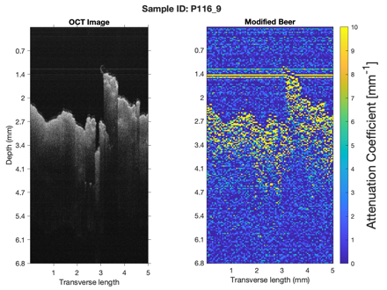 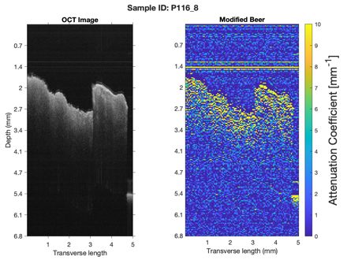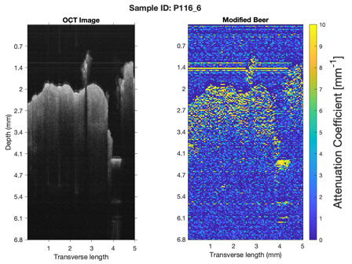

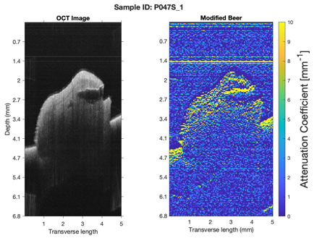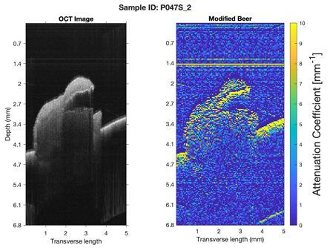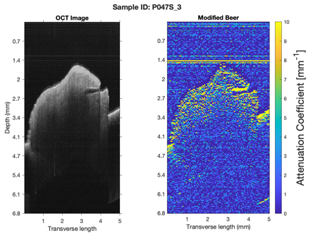

**Figure 17**. Examples of images with optical artifacts that make it difficult to select good regions of interest. The top 3 images are showing optical “wraparound” of the tissue that does not truly exist. The bottom 3 images do not contain artifacts, however, the large “tear” that can be seen in the tissue makes it difficult to select a region while avoiding the air.

After this quality control step, we confirmed that our attenuation coefficients were normally distributed in each group using the Shapiro-Wilk normality, obtaining p-values of 0.225 and 0.263 for cancer and hyperkeratosis, respectively. Using Welch’s t-test, we obtained a p-value = 0.0365, indicating that there is evidence to suggest that the attenuation coefficients are significantly different between cancer and hyperkeratosis samples.

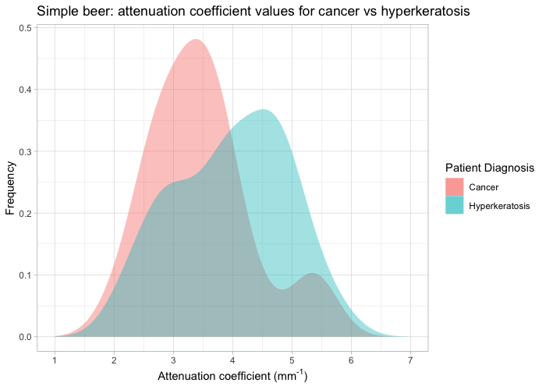

**Figure 18. After quality control of data.** Density plots of attenuation coefficients calculated using the Simple Beer-Lambert Model. Distributions for cancer samples (red) and hyperkeratosis samples (blue). Density plots created using the R package ggplot2.

From **Figure 18**, we observe that the previous bimodal distribution for cancer attenuation coefficients is less pronounced compared to before applying quality control to the data. There remains some overlap between the distributions of cancer and hyperkeratosis attenuation coefficients, however we obtained a significant p-value (0.0365) to suggest that there is a difference between the two groups.

It is critical to emphasize the importance of selecting appropriate regions within tissue images when calculating an average attenuation coefficient. Prior to performing quality control, we observed that there were some images containing optical artifacts that were affecting attenuation coefficient values, resulting in non-normally distributed data.

**Discussion**

Additional statistical tests and considerations are required to increase the power of our conclusions. However, we have preliminary evidence to suggest that OCT can play a role as a tool in dental clinics for improving clinicians’ capacity to screen for oral cancer. OCT can be useful for identifying early changes in oral epithelium and identifying potentially malignant lesions. As well, OCT can be valuable for post-treatment surveillance of patients who have had a tumor surgically excised from their mouth. That is, OCT can be used for reevaluating the area of excision for identifying tumor recurrence.

In some cases, oral lesions can be very large, or contain several areas with distinct appearances. This can make it difficult to determine the best place taking a biopsy to perform a histopathological diagnosis. OCT may be able to help with determining the area of the lesion where squamous cell carcinoma is most likely to be present.

A large portion of this project was developing and validating a methodology for OCT data analysis. We confirmed that our models were computing relatively accurate attenuation coefficients when compared to previous methods. The attenuation coefficients calculated for intralipid liquid phantoms were similar when compared to a paper from Faber et al.21

Similar to the study by Yang et al.,4 our model was able to determine significant differences in attenuation coefficients between cancer and non-cancer oral tissue. However, Yang et al were also able to determine the sensitivity and specificity of their model by dividing their data into training and validation datasets. They trained their model using a subset of their data to determine a threshold to separate cancer from non-cancer. Then they classified their remaining data based on whether their attenuation coefficients were below or above the threshold, and compared them to the real pathological diagnoses. It was not possible for us to subset our data due to the small number of SCC samples. But we also have lesions with many additional diagnoses, not limited to just cancer and non-cancer. Further tests with our dataset can yield conclusions regarding a vast spectrum of oral malignancies.

A study by Sunny et al.9 investigated the utility of OCT for surgical margin delineation around a tumor. Cancerous lesions are heterogeneous and it is not obvious where they end and where normal tissue begins. Sunny et al. found that OCT could sufficiently distinguish between cancer and normal cells. It can effectively determine surgical boundaries, such that leaving positive margins is less likely when compared to the typical clinical determination of surgical boundaries. This finding presents significant implications for decreasing the rate of tumor recurrence.

*Limitations*

The models we investigated in our analysis (Beer-Lambert with and without a CPSF) both assume only single-scattering events. Multiple scattering events can occur when photons scattered from the tissue are re-scattered from neighbouring particles before returning to the photodetector. These multi-scattering events are not considered in our models and might play a role in our calculated attenuation coefficients.

Our analysis chose to only compare differences between the opposite ends of the spectrum of oral cancer (cancer vs benign). As a result, although we have biopsies from 248 patients included in our dataset, the sample size of our analysis is small (after quality control: 6 patients, 18 images for cancer and 18 patients, 54 images for hyperkeratosis). The data from the remaining 224 patients who were diagnosed with other types of lesions would be interesting to investigate to form stronger conclusions about what can and cannot be determined from the optical properties of oral tissue. Due to the small sample size for SCC tissues, differences in tissue composition are amplified in the results, and the peaks that we observe in our distributions may be occurring by chance.

Region selection within tissues has proven challenging. Because OCT is generating an interference pattern to represent light-matter interactions, rather than taking “pictures/photos”, it is difficult to relate the OCT images with the histological slides of biopsies. It is difficult to know exactly where in the tissue we are selecting our region, whether it captures epithelial tissue, or connective tissue. The cell types present in the regions that we selected (epithelium, collagen, fibroblasts, etc.) may influence the calculated attenuation coefficients.

The calculations in our analysis included a variety of parameters that can be adjusted. We ran our analysis while deciding on just a single value for all parameters, but varying our analysis would be critical for ensuring that our results explain real information, rather than being just a product of our chosen parameters. For example, it was mentioned that we used 5-pixel-by-5-pixel blocks for averaging within images. Alternative sizes for these blocks might also be appropriate, as we cannot say for certain that 5 pixels is adequate for capturing differences in spatial areas of the tissue.

*Future directions*

For continuation of this work in the future, we would like to vary our data analysis. This would include experimentation with different parameters and settings for calculating attenuation coefficients. For example, the block size used for averaging in our analysis was 5-pixels-by-5-pixels. It is uncertain whether this is the best method, so we would like to run comparisons between different block sizes. Varying our analysis would be advantageous for further exploration of methodologies used in OCT computational analysis.

Our models can be applied to various other types of lesions. We only analyzed the extreme ends of the spectrum of oral cancer. Learning more about how OCT can discriminate between levels of dysplasia will reveal more about the power of OCT in oral cancer research.

An investigation on the effect of the anatomical site of biopsy on attenuation coefficients might reveal important considerations for dentists if ever OCT is adopted into real clinical practice.

Region selection is an area with a lot of potential for improvement. For example, it may be possible to implement a method of algorithmic segmentation to the tissues to separate different areas like the epithelium and the lamina propria. This would help with customization of the region of interest, to be certain that our regions are capturing areas that are comparable between tissues.

**Conclusion**

This project investigated the utility of optical coherence tomography for oral cancer screening. It can be difficult to classify the type of oral lesion using just the superficial appearance. OCT is a light interference imaging technique that can obtain high-resolution images of oral tissue. We explored methods of computationally analyzing OCT data to model light attenuation. The approach of our models was to incorporate principles of the Beer-Lambert law and apply curve fitting parameters to compute attenuation coefficients. We validated our methods by testing with intralipid and comparing with the intralipid results from past literature.

Attenuation coefficients were tested for statistically significant differences between different pathological diagnoses. We found that the attenuation coefficients calculated using our models were able to identify significant differences in OCT images for squamous cell carcinoma and hyperkeratosis oral tissue (p = 0.0365). There is evidence that OCT can discriminate between cancer and hyperkeratosis oral lesions. OCT data and quantitative analysis have the potential to play a valuable role in oral cancer screening to detect malignant and potentially malignant diseases.

**References**

1. Smith L, Cancer Society C, John S, et al. Members of the Canadian Cancer Statistics Advisory Committee Analytic leads. Published online 2019.

2. Oral cancer. Government of Canada.

3. Mouth cancer. Mayo Foundation for Medical Education and Research (MFMER).

4. Yang Z, Shang J, Liu C, Zhang J, Liang Y. Identification of oral cancer in OCT images based on an optical attenuation model. *Lasers in Medical Science*. 2020;35:1999-2007. doi:10.1007/s10103-020-03025-y/Published

5. Badri P, Ganatra S, Baracos V, Lai H, Amin M. Oral Cavity and Oropharyngeal Cancer Surveillance and Control in Alberta: A Scoping Review. *J Can Dent Assoc*. 2021;87:4.

6. Speight PM, Epstein J, Kujan O, et al. Screening for oral cancer—a perspective from the Global Oral Cancer Forum. *Oral Surgery, Oral Medicine, Oral Pathology and Oral Radiology*. 2017;123(6):680-687. doi:10.1016/j.oooo.2016.08.021

7. Rethman MP, Carpenter W, Cohen EEW, et al. Evidence-based clinical recommendations regarding screening for oral squamous cell carcinomas. *Journal of the American Dental Association*. 2010;141(5):509-520. doi:10.14219/jada.archive.2010.0223

8. Yang Z, Shang J, Liu C, Zhang J, Liang Y. Identification of oral cancer in OCT images based on an optical attenuation model. *Lasers in Medical Science*. 2020;35:1999-2007. doi:10.1007/s10103-020-03025-y/Published

9. Sunny SP, Agarwal S, James BL, et al. Intra-operative point-of-procedure delineation of oral cancer margins using optical coherence tomography. *Oral Oncology*. 2019;92:12-19. doi:10.1016/j.oraloncology.2019.03.006

10. David F. Wilson, Jiang De-Jun, Angela M. Pierce, Ole W. Wiebkin. Oral cancer: Role of the basement membrane in invasion. *Australian Dental Journal*. 1999;44(2):93-97.

11. Güneri P, Epstein JB, Kaya A, Veral A, Kazandi A, Boyacioglu H. The utility of toluidine blue staining and brush cytology as adjuncts in clinical examination of suspicious oral mucosal lesions. *International Journal of Oral and Maxillofacial Surgery*. 2011;40(2):155-161. doi:10.1016/j.ijom.2010.10.022

12. The OralCDx Brush Test - Oral Brush Biopsy | CDx Diagnostics. Accessed November 30, 2021. https://www.cdxdiagnostics.com/oralcdx

13. Frydkjaer-Olsen U, Hansen RS, Peto T, Grauslund J. Structural neurodegeneration correlates with early diabetic retinopathy. *International Ophthalmology*. 2018;38(4):1621-1626. doi:10.1007/s10792-017-0632-1

14. Fatakdawala H, Poti S, Zhou F, et al. Multimodal in vivo imaging of oral cancer using fluorescence lifetime, photoacoustic and ultrasound techniques. *Biomedical Optics Express*. 2013;4(9):1724. doi:10.1364/boe.4.001724

15. Sadr A, Shimada Y, Mayoral JR, et al. Swept source optical coherence tomography for quantitative and qualitative assessment of dental composite restorations. In: *Lasers in Dentistry XVII*. Vol 7884. SPIE; 2011:78840C. doi:10.1117/12.877351

16. Wasatch Photonics. Spectral-Domain Optical Coherence Tomography: Ultra-High Resolution Ophthalmic Imaging.

17. Yonetsu T, Bouma BE, Kato K, Fujimoto JG, Jang IK. Optical coherence tomography: 15 years in cardiology. *Circulation Journal*. 2013;77(8):1933-1940. doi:10.1253/circj.CJ-13-0643.1

18. Tsai TH, Leggett CL, Trindade AJ. Optical coherence tomography in gastroenterology: a review and future outlook. *Journal of Biomedical Optics*. 2017;22(12):1. doi:10.1117/1.jbo.22.12.121716

19. Jerjes W, Hamdoon Z, Hopper C. Structural validation of facial skin using optical coherence tomography: A descriptive study. *Skin Research and Technology*. 2020;26(2):153-162. doi:10.1111/srt.12791

20. Yifeng Zeng, bin Rao, William C. Chapman Jr., et al. The angular spectrum of the scattering coefficient map reveals subsurface colorectal cancer. *Nature*. Published online 2019. www.nature.com/scientificreports

21. Faber DJ, van der Meer FJ, Aalders MC, et al. *Quantitative Measurement of Attenuation Coefficients of Weakly Scattering Media Using Optical Coherence Tomography*. Vol 254.; 2004.

22. Vermeer KA, Mo J, Weda JJA, Lemij HG, de Boer JF. Depth-resolved model-based reconstruction of attenuation coefficients in optical coherence tomography. *Biomedical Optics Express*. 2014;5(1):322. doi:10.1364/boe.5.000322

23. Faber DJ, van der Meer FJ, Aalders MC, et al. Optical Coherence Tomography; (170.4500) Optical Coherence Tomography; (170.3880) Medical and biological imaging. *Science (1979)*. 1991;254:1178-1181.

24. Vermeer KA, Mo J, Weda JJA, Lemij HG, de Boer JF. Depth-resolved model-based reconstruction of attenuation coefficients in optical coherence tomography. *Biomedical Optics Express*. 2014;5(1):322. doi:10.1364/boe.5.000322

25. MATLAB. (R2021a). *Natick, Massachusetts: The Mathworks Inc*. Published online 2021.

26. Barry K. Moser, Gary R. Stevens. Homogeneity of Variance in the Two-Sample Means Test. *The American Statistican*. 1992;46(1):19-21. doi:https://doi.org/10.2307/2684403

27. R Core Team. R: A language and environment for statistical computing. *R Foundation for Statistical Computing*. 2021;(https://www.R-project.org/).

28. Lu ZL, Yuan KH. Welch’s t test. *ResearchGate*. Published online 2010. doi:10.13140/RG.2.1.3057.9607